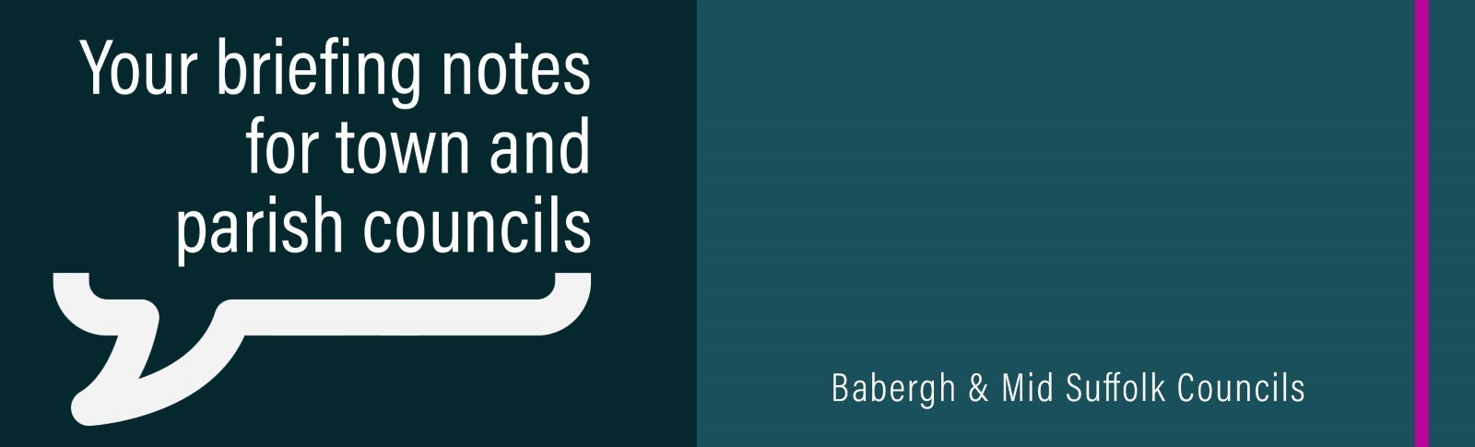
Councils have ‘no option’ but to review Joint Local Plan after Government’s huge housebuilding hike
Babergh and Mid Suffolk District Councils say a huge rise in housebuilding requirements set by the Government has left no option but to review their Joint Local Plan.
Mid Suffolk District Council pledges unanimous support for farmers
Councillors from across Mid Suffolk’s political divide have come together to pledge their support for the district’s farmers, in the face of challenges that could undermine the farming sector and threaten the nation’s food supply.

Council orders immediate closure of A14 Elmswell Services over planning breaches
Mid Suffolk District Council has ordered the immediate closure of EG On The Move’s Elmswell Services for failing to implement essential road safety measures. This further update on the owners’ failure to close has subsequently been shared to our social media channels.
Community groups receive funding to help people ‘live well’ this winter
A total of 25 community projects across Babergh and Mid Suffolk have each received a share of more than £31,000 to keep residents warm, active and connected over winter.
International relations blossom as Tokyo looks to learn from Babergh and Mid Suffolk
Babergh and Mid Suffolk District Councils have hosted a delegation from the Tokyo Metropolitan Government – showcasing their pioneering tree canopy survey.
Funding from Mid Suffolk District Council
Various grant windows are currently open, giving community organisations the chance to secure crucial funding to support community projects. For more details, visit the website.
Fuel support information on our website
A fuel support flyer has been published on our website, signposting local resources that could help those struggling to heat their homes. Find it on the energy, fuel and utilities section of the website.
Mid Suffolk’s independent living service
Babergh and Mid Suffolk's Independent Living Service (ILS) aims to encourage independence at home, by providing a supportive network across the county. We would appreciate any support in sharing our poster and raising awareness of the scheme.

