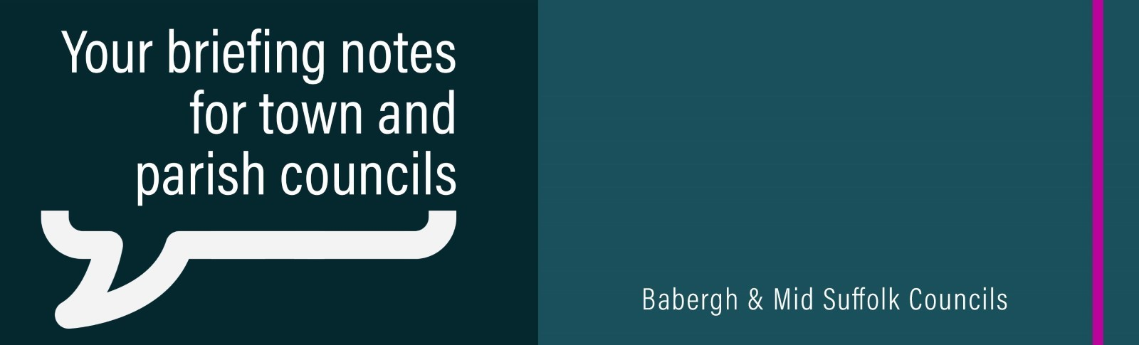
Leader’s response to Devolution White Paper
Leader of Mid Suffolk District Council, Cllr Andy Mellen said: “I remain open-minded about reorganisation as long as it is done in the right way and has the interests of our residents at its heart...
Statement in response to Government's National Planning Policy Framework announcement
Statement from Cllr Andrew Stringer, Mid Suffolk’s portfolio holder for Heritage, Planning and Infrastructure, following today's announcement about the National Planning Policy Framework.
Council tax freeze proposed in Mid Suffolk
Mid Suffolk District Council proposes to freeze its element of council tax for the upcoming financial year – helping residents to navigate the cost-of-living crisis while continuing investment in priority areas to improve quality of life in the district.
Full speed ahead for £18m Skills and Innovation Centre
Mid Suffolk District Council’s plans for an £18m Skills and Innovation Centre in Stowmarket have taken a major step forward.
Mid Suffolk communities set to receive almost £700k in cash boost from developers
Three projects in Mid Suffolk are set to receive a share of £691k from Mid Suffolk District Council, with money collected from developers set to fund new sports facilities, the expansion of a college and keep long-awaited rail improvements on track.
Suffolk Public Sector Leaders Group endorse the Suffolk Economy Strategy
New strategy aims to propel Suffolk’s economic growth and position the county at the forefront of the UK’s green evolution
Ready, steady, grow! - £0.5m boost for sports and wellbeing proposed for Stowmarket
Stowmarket could be about to receive almost £500,000 from developer contributions towards new sports and healthy activity facilities in the town.
Funding from Mid Suffolk District Council
Do you want to know more about the funding opportunities available from Mid Suffolk District Council?
Visit our new-look webpage which has all the information you need, including a breakdown of our grants, what they are for, and how you can apply. This includes our new Community Development Grants, and our Pride in Your Place grants.
For more details, visit the website.
